Guided Capstone Project Report

**Business Problem:** How can Big Mountain Ski Resort bring in additional revenue to pay for the new speed quad lift investment? The main problem is to predict the adult weekend ticket price for ski resorts. This will allow Big Mountain Ski Resort to raise ticket prices to generate revenue.

As the data scientist for this project, the steps included data wrangling, exploratory data analysis, preprocessing, and training and modeling.

A scatter plot was developed to analyze the average ticket price for each state. The state of Montana show component one equal to one and the second component between zero and one. Further analysis was carried out to determine the difference between weekend and weekday ticket prices.

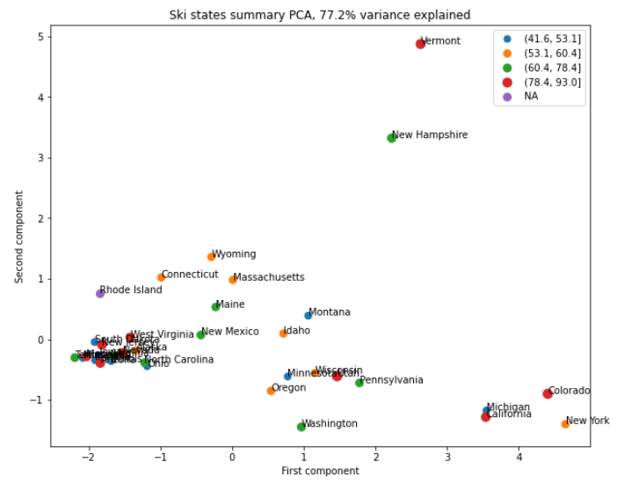

A correlation heat map shows the relationship between variables. This is very helpful in that vertical drop, runs, longest run, skiable terrain, and weekend and weekday ticket prices are highly correlated. This allowed us to further investigation the importance of each of these variables.

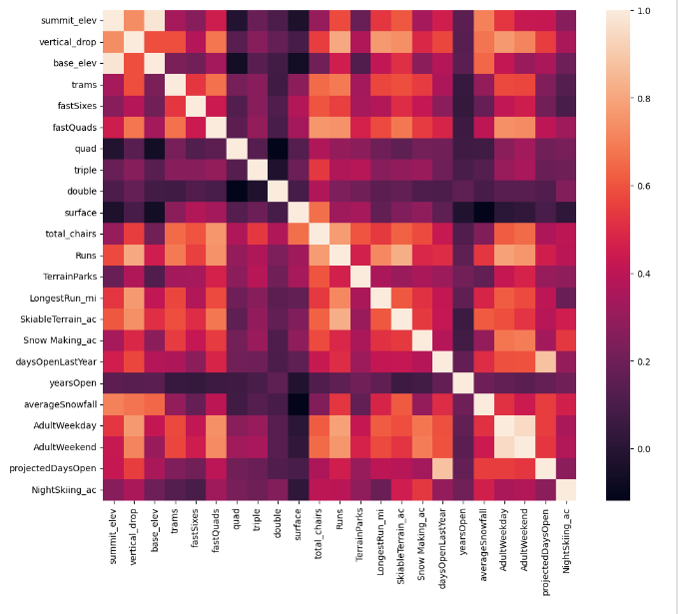

A best linear model and best random forest model were developed, the random forest was used in that it had a lower cross-validation mean absolute error by almost $1, exhibited less variability, and produced consistent results along with the cross-validation results.

Three scenarios were investigated:

1. Close up to 10 runs
2. Increase the vertical drop by 150 feet
3. Add 2 acres for snowmaking
4. Increase the longest run by 0.2 miles

Summary:

In conclusion, closing 6 or more runs would cause a large drop in ticket prices. Increasing the vertical drop and adding a ski lift would support the increase of ticket prices by $1.99 which would result in $3,474,638 in revenue. The above result is true if the resort increases the snow-making by 0.2 acres. While increasing, the longest run shows no benefit.

Executive suggestion:

After careful analysis, 3 options were found to help the revenue stream of Big Mountain Resort.

1. Keep everything the same while raising ticket prices by $1, increasing revenue by $3,400,000 per season.
2. Increase the vertical drop and raise ticket prices by $1.99, which increases revenue by $3,474,638 per season.
3. Increase snow-making by 0.2 acres and raise ticket prices by $1.99, which increases revenue by $3,474,638 per season.